**Results Template**

A Subtitle

## 0.1 Packages

# 1 Introduction

# 2 Sliding windows

import sys  
sys.path.insert(1, 'libs/')  
  
import dynfc as dyn  
import numpy as np  
from numpy.random import seed, rand  
import scipy as sc  
from scipy import io  
import seaborn as sns  
import matplotlib.pyplot as plt  
import matplotlib.cbook as cbook  
import matplotlib.cm as cm  
import matplotlib.patches as patches  
  
font = {'weight' : 'regular',  
 'size' : 24}  
plt.rc('font', **font)  
  
ts = sc.io.loadmat('data/ts.mat')['ts']  
ts = ts.transpose()  
  
corr_mats, idx = dyn.corr_slide(ts,300,50)  
  
idx.shape

> (24,)

a = [1,1,1,1,1.6]  
  
fig,ax = plt.subplots(1)  
fig.set_figheight(10)  
fig.set_figwidth(20)  
plt.style.use('tableau-colorblind10')  
for i in range(5):  
   
 plt.plot(2*i*a[i] + ts[i,]/1.4)

> [<matplotlib.lines.Line2D object at 0x7f81c2f12748>]  
> [<matplotlib.lines.Line2D object at 0x7f82325e8860>]  
> [<matplotlib.lines.Line2D object at 0x7f82c4090748>]  
> [<matplotlib.lines.Line2D object at 0x7f82325e8f60>]  
> [<matplotlib.lines.Line2D object at 0x7f818655d2b0>]

plt.xlabel('Time [TRs]')

> Text(0.5, 0, 'Time [TRs]')

plt.ylabel('BOLD')

> Text(0, 0.5, 'BOLD')

ax.tick_params(left=False)  
ax.set_yticklabels([])

> [Text(0, -2.0, ''), Text(0, 0.0, ''), Text(0, 2.0, ''), Text(0, 4.0, ''), Text(0, 6.0, ''), Text(0, 8.0, ''), Text(0, 10.0, ''), Text(0, 12.0, ''), Text(0, 14.0, '')]

ax.set_ylim(-3,15.4)

> (-3.0, 15.4)

ax.set_xlim(0,1200)

> (0.0, 1200.0)

rect = patches.Rectangle((idx[0],-2.8),300,18,linewidth=4,edgecolor='#595959',facecolor='none')  
ax.add_patch(rect)

> <matplotlib.patches.Rectangle object at 0x7f817fe47438>

rect = patches.Rectangle((idx[5],-2.8),300,18,linewidth=4,edgecolor='#A56B6B',facecolor='none')  
ax.add_patch(rect)

> <matplotlib.patches.Rectangle object at 0x7f817fe47dd8>

rect = patches.Rectangle((idx[9],-2.8),300,18,linewidth=4,edgecolor='#CE3E3E',facecolor='none')  
ax.add_patch(rect)

> <matplotlib.patches.Rectangle object at 0x7f817fe51128>

rect = patches.Rectangle((idx[16],-2.8),300,18,linewidth=4,edgecolor='#FF0000',facecolor='none')  
ax.add_patch(rect)

> <matplotlib.patches.Rectangle object at 0x7f817fe51438>

plt.show()



import sys  
sys.path.insert(1, 'libs/')  
  
import dynfc as dyn  
import numpy as np  
from numpy.random import seed, rand  
import scipy as sc  
from scipy import io  
import seaborn as sns  
import matplotlib.pyplot as plt  
import matplotlib.cbook as cbook  
import matplotlib.cm as cm  
import matplotlib.patches as patches  
  
aa = plt.figure(figsize = [6,6])  
ax = sns.heatmap(corr_mats[:,:,0],   
 cmap = "RdBu_r",   
 vmin = -1,   
 vmax = 1,   
 square = True,   
 cbar = False)  
ax.axis('off')

> (0.0, 200.0, 200.0, 0.0)

ax.tick_params(left=False, bottom=False)  
   
plt.show()

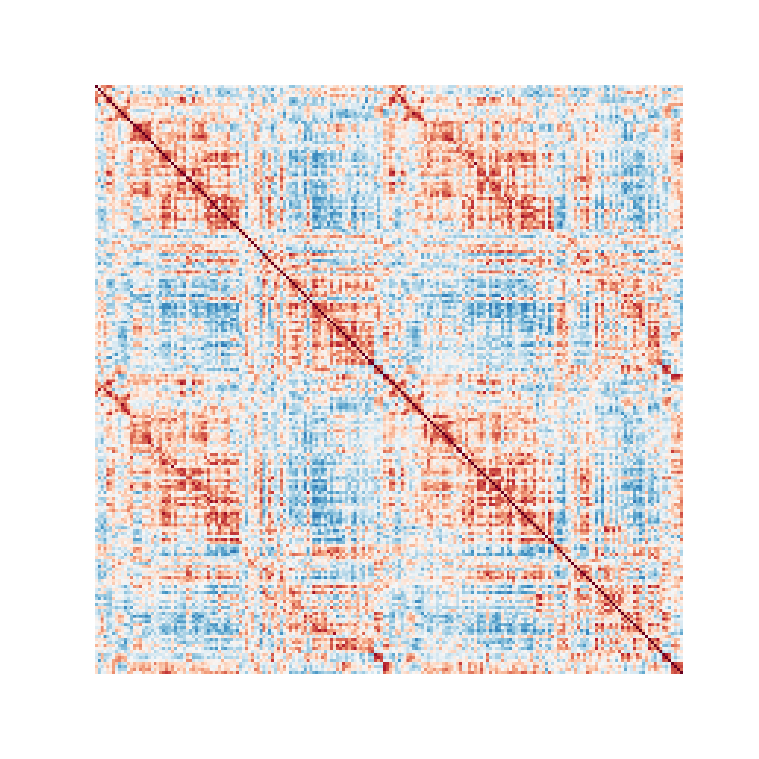

aa = plt.figure(figsize = [6,6])  
ax = sns.heatmap(corr_mats[:,:,5],   
 cmap = "RdBu_r",   
 vmin = -1,   
 vmax = 1,   
 square = True,   
 cbar = False)  
ax.axis('off')

> (0.0, 200.0, 200.0, 0.0)

ax.tick_params(left=False, bottom=False)  
   
plt.show()

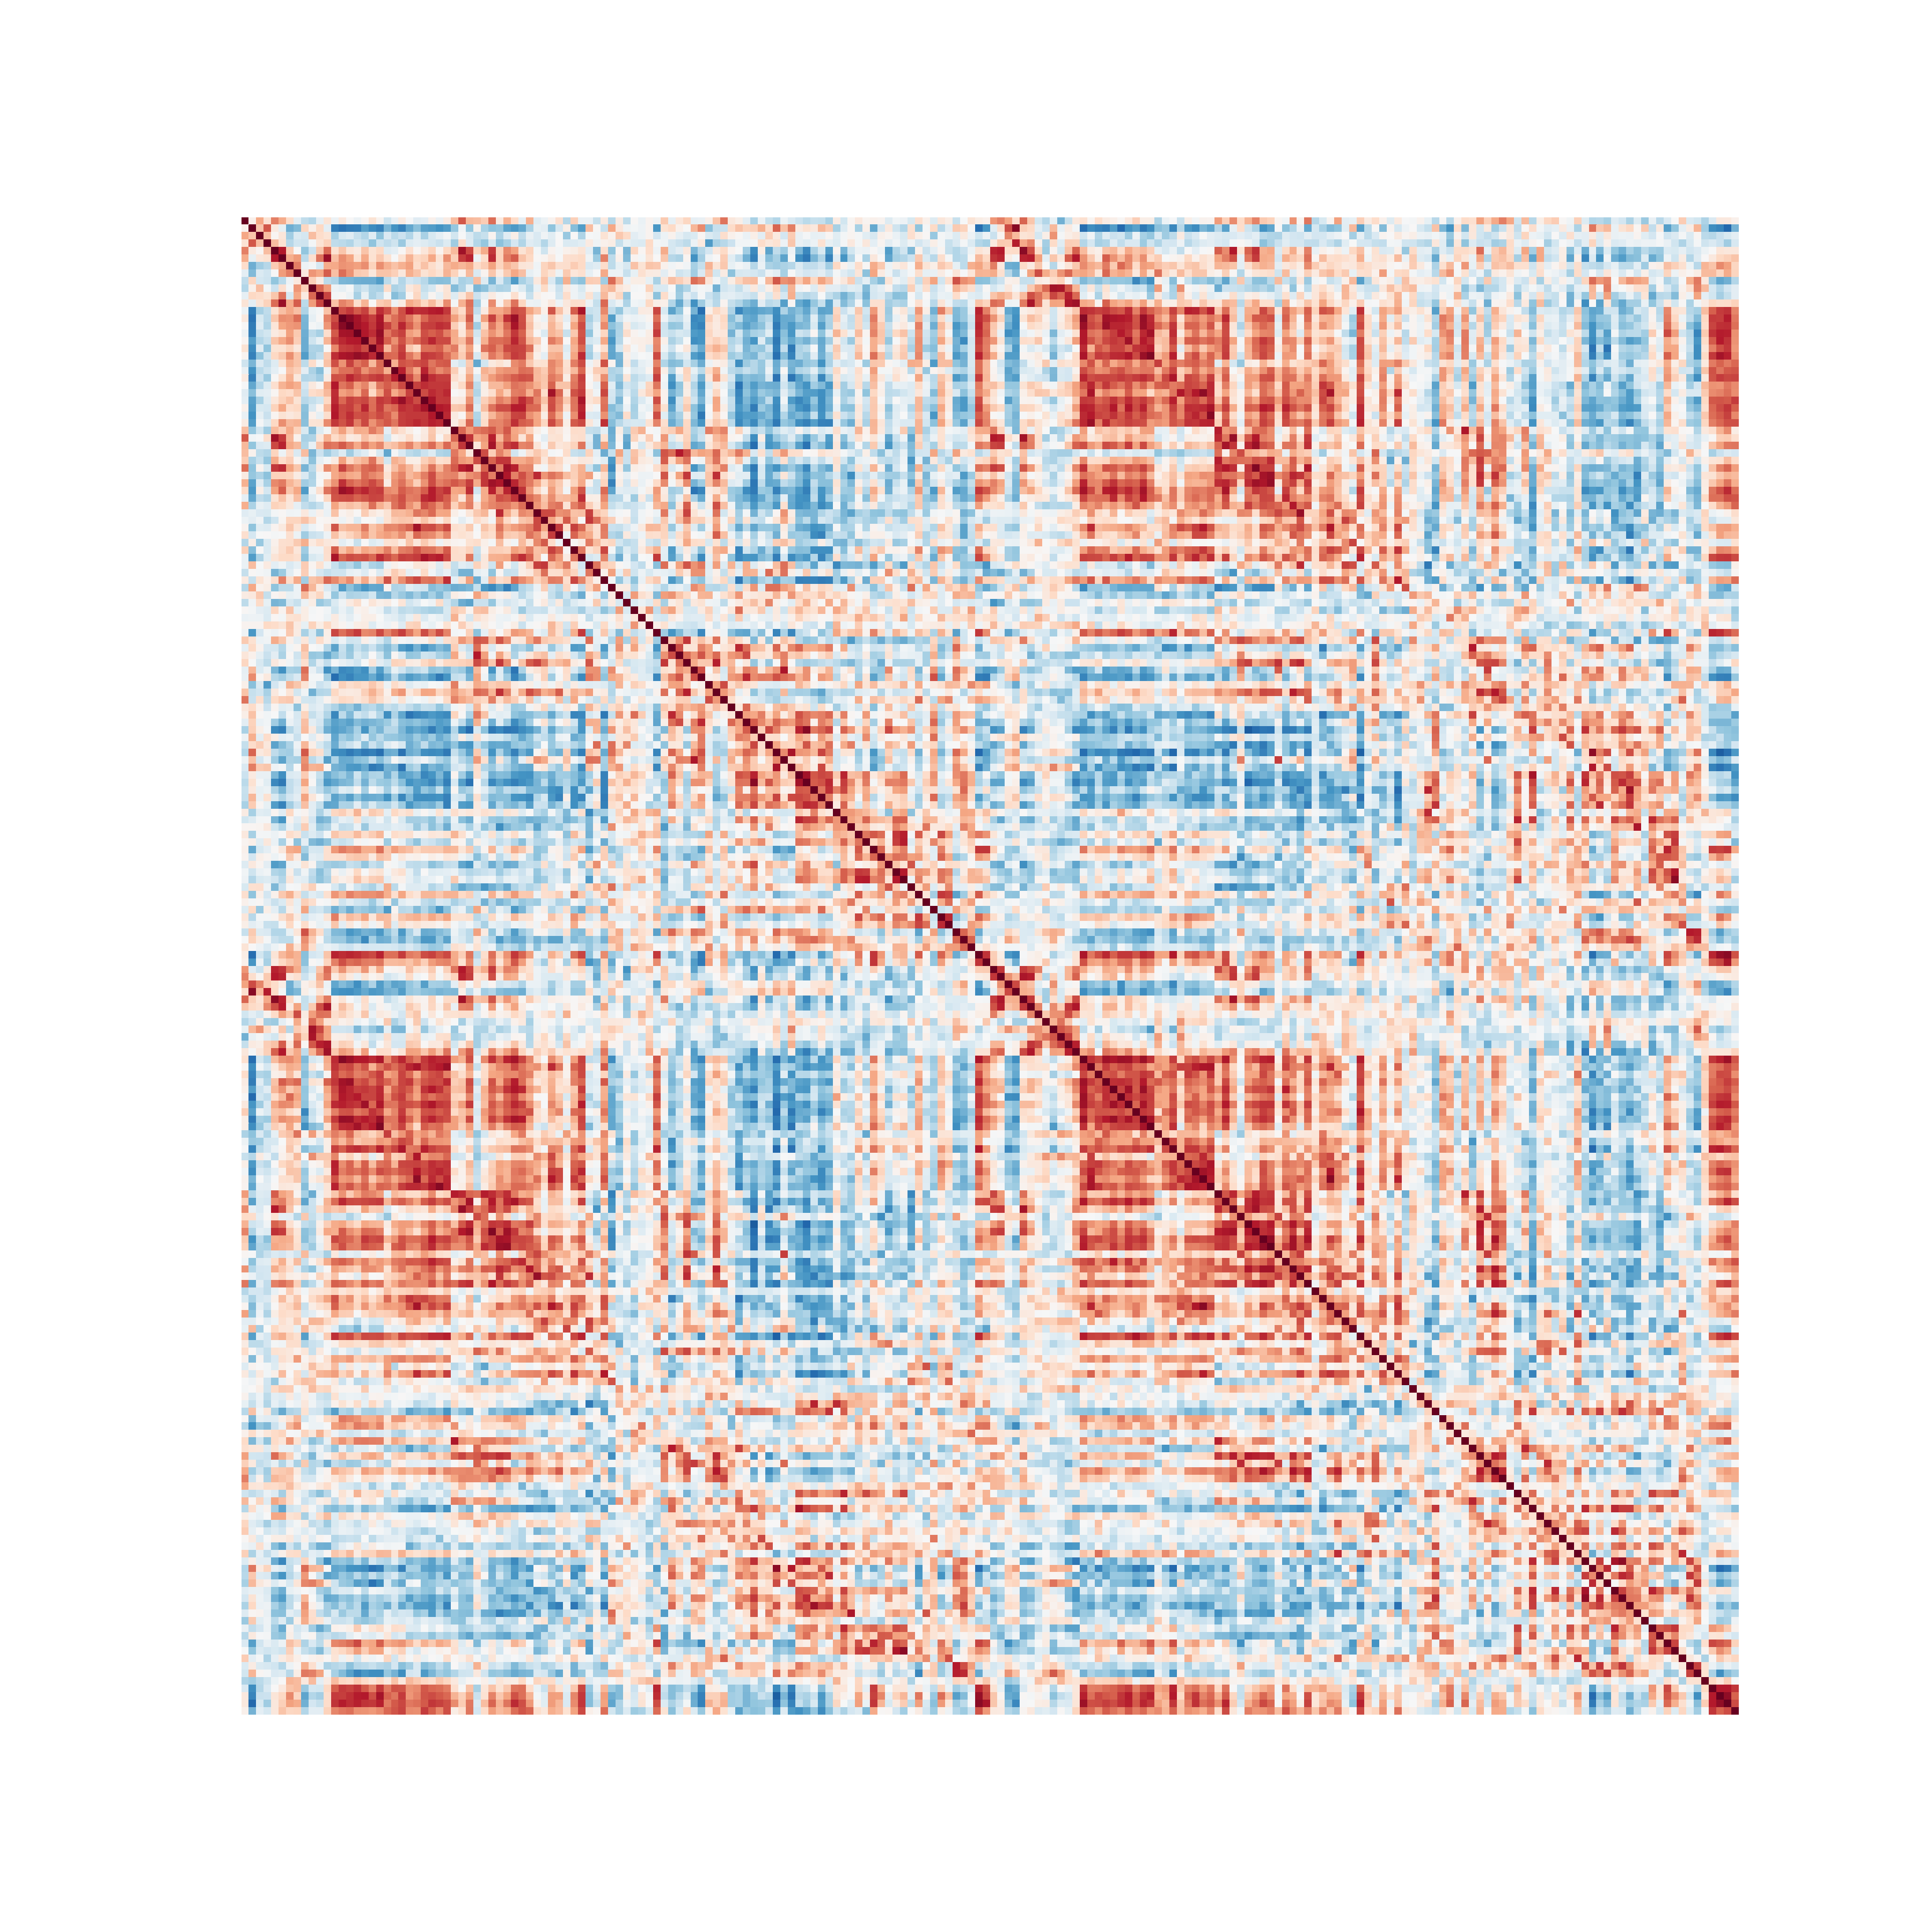

aa = plt.figure(figsize = [6,6])  
ax = sns.heatmap(corr_mats[:,:,9],   
 cmap = "RdBu_r",   
 vmin = -1,   
 vmax = 1,   
 square = True,   
 cbar = False)  
ax.axis('off')

> (0.0, 200.0, 200.0, 0.0)

ax.tick_params(left=False, bottom=False)  
   
plt.show()

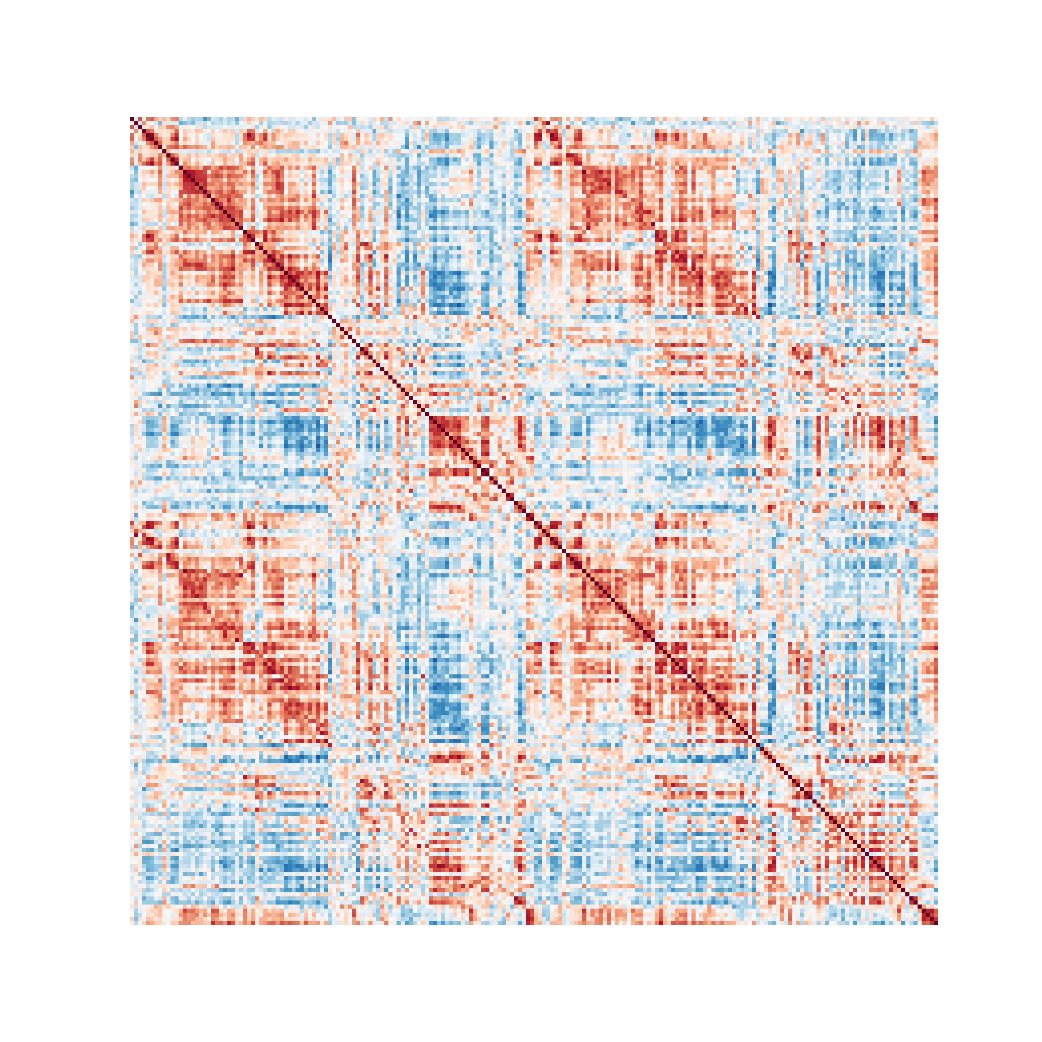

aa = plt.figure(figsize = [6,6])  
ax = sns.heatmap(corr_mats[:,:,16],   
 cmap = "RdBu_r",   
 vmin = -1,   
 vmax = 1,   
 square = True,   
 cbar = False)  
ax.axis('off')

> (0.0, 200.0, 200.0, 0.0)

ax.tick_params(left=False, bottom=False)  
   
plt.show()

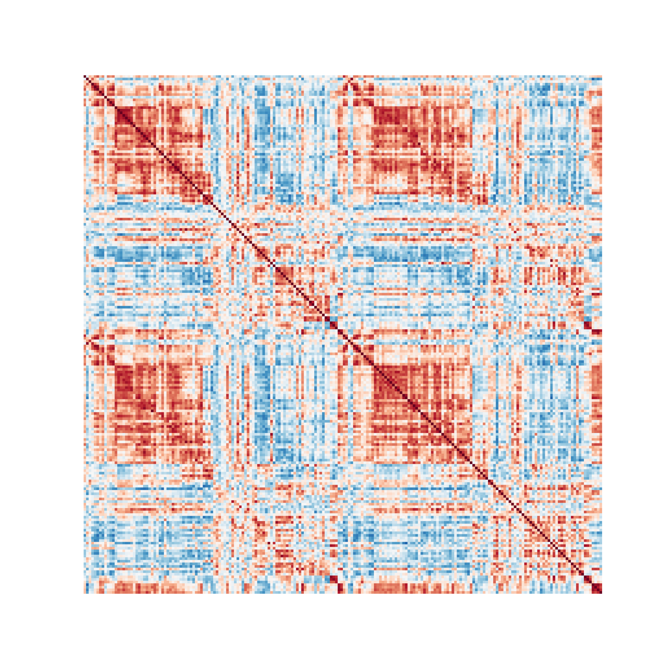

# 3 Cofluctuations

import sys  
sys.path.insert(1, 'libs/')  
  
import numpy as np  
import scipy as sc  
from scipy import io  
import dynfc as dyn  
import seaborn as sns  
import matplotlib.pyplot as plt  
  
ts = sc.io.loadmat('data/ts.mat')['ts']  
ts = ts.transpose()  
  
mat1, rss = dyn.corr_slide(ts,24)  
mat1 = mat1[:,:,0]  
  
aa = plt.figure(figsize = [6,6])  
ax = sns.heatmap(mat1,   
 cmap = "RdBu_r",   
 vmin = -1,   
 vmax = 1,   
 square = False,   
 cbar = True)  
ax.axis('off')

> (0.0, 200.0, 200.0, 0.0)

ax.tick_params(left=False, bottom=False)  
plt.show()

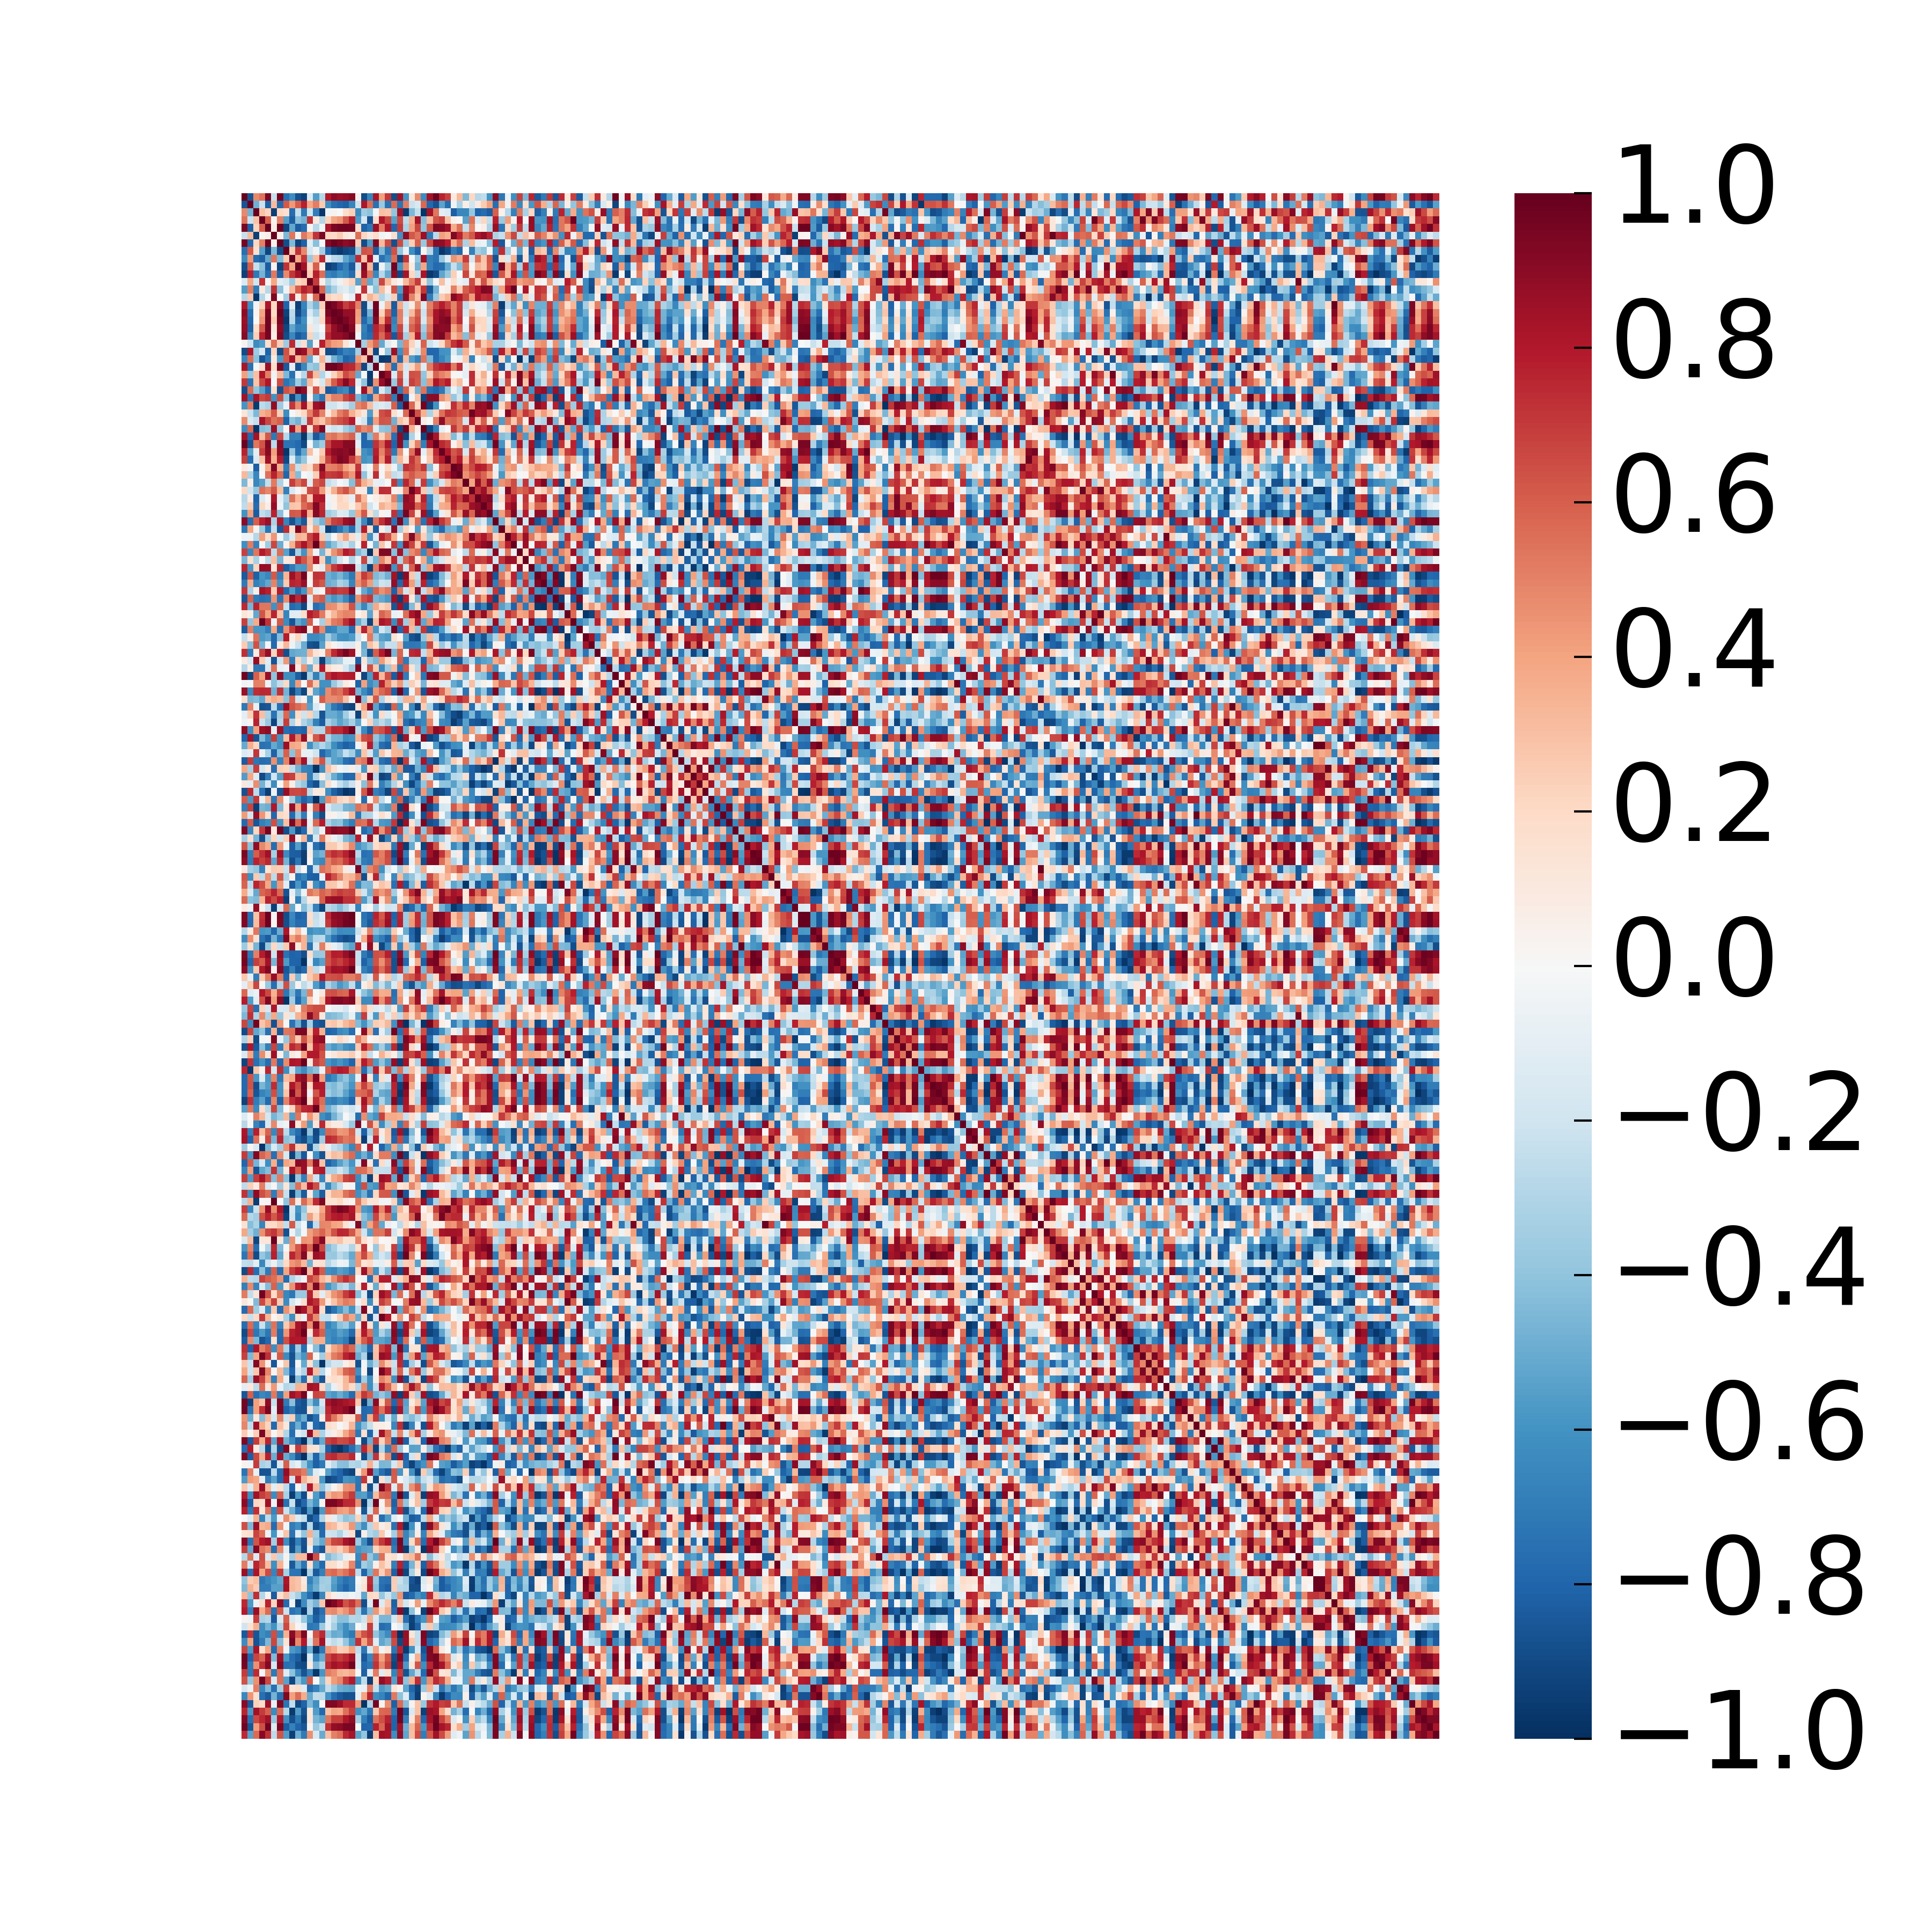

upt = np.triu_indices(mat1.shape[0], k = 1)  
vec = (mat1[upt])  
  
toPlot = np.zeros((vec.shape[0],1))  
toPlot[:,0] = vec  
  
aa = plt.figure(figsize = (12/50,4))  
ax = sns.heatmap(toPlot[:,0:1],   
 cmap = "RdBu_r",   
 vmin = -1,   
 vmax = 1,   
 square = False,   
 cbar = False)  
ax.axis('off')

> (0.0, 1.0, 19900.0, 0.0)

plt.show()



edges_series, corr_mats, rss = dyn.cofluct(ts, 24)  
  
aa = plt.figure(figsize = (12,4))  
ax = sns.heatmap(edges_series,   
 cmap = "RdBu_r",   
 vmin = -1,   
 vmax = 1,   
 square = False,   
 cbar = False)  
ax.axis('off')

> (0.0, 1200.0, 19900.0, 0.0)

plt.show()

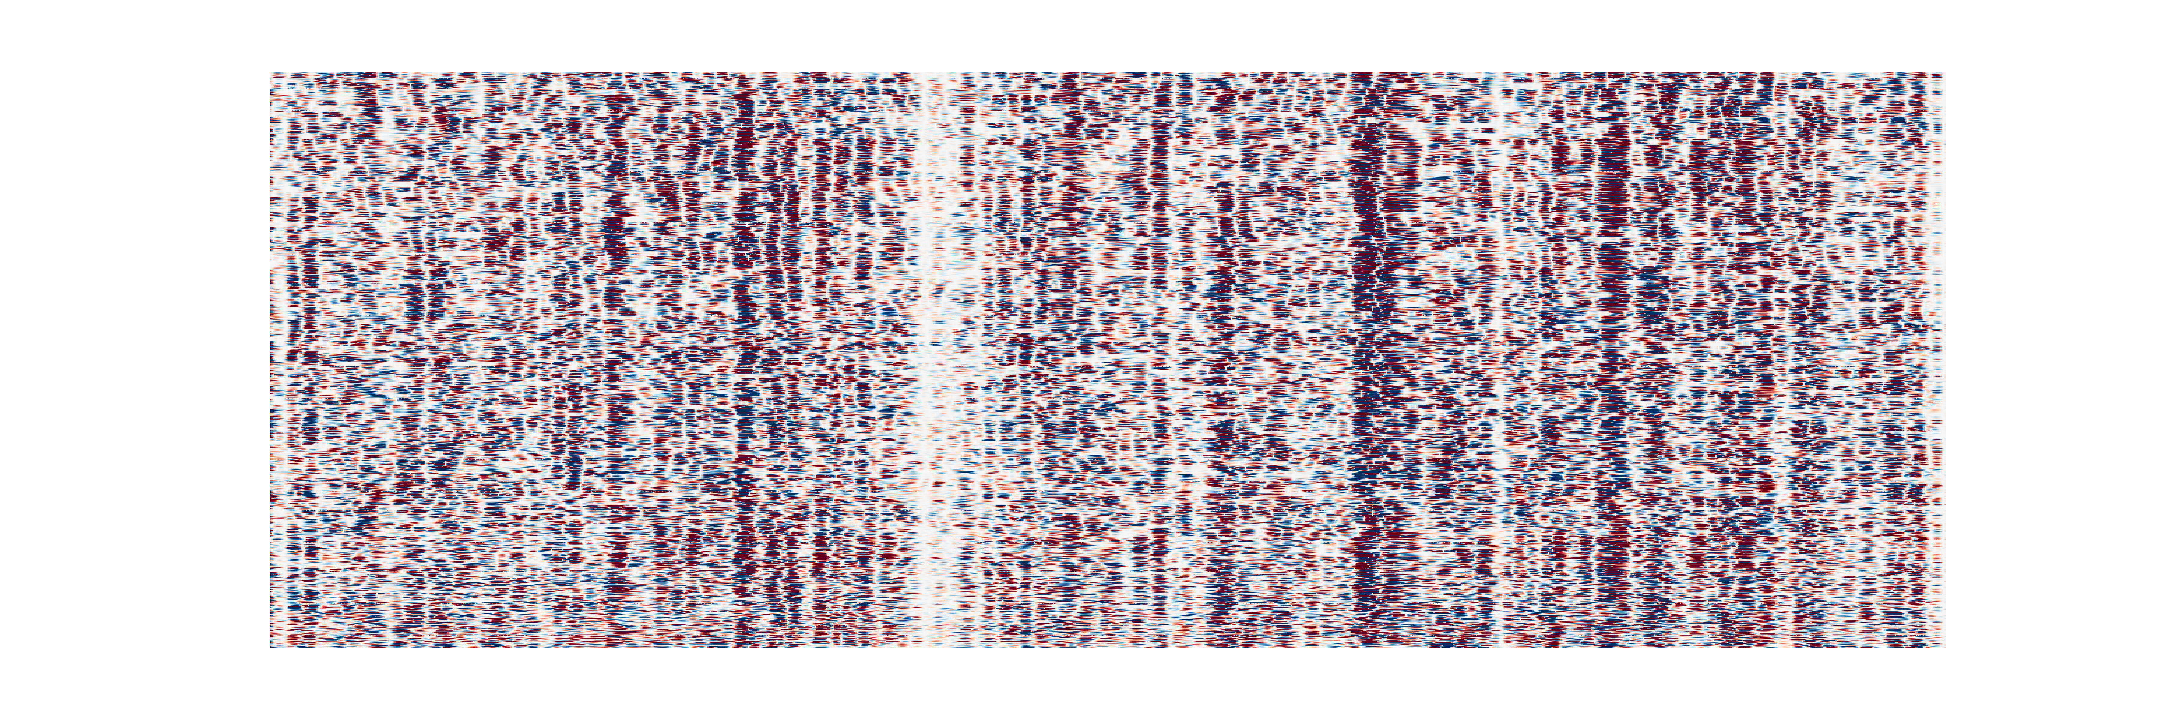

#Phase difference

import sys  
sys.path.insert(1, 'libs/')  
  
import numpy as np  
import matplotlib.pyplot as plt  
import matplotlib.patches as patches  
from mpl_toolkits.mplot3d import Axes3D  
  
theta = np.linspace(0*np.pi, 8*np.pi, 100)  
time = np.linspace(0, 8, 100)  
y1 = np.sin(theta)  
x1 = np.cos(theta)  
y2 = np.sin(theta + np.pi/2)  
x2 = np.cos(theta + np.pi/2)  
r = time/np.max(time)  
ones = np.ones(time.shape[0])  
  
fig = plt.figure()  
ax = fig.add_subplot(projection='3d')  
plt.style.use('classic')  
  
ax.plot(time, x1, y1, color = '#67001f', linewidth=2)

> [<mpl_toolkits.mplot3d.art3d.Line3D object at 0x7f8230ab66a0>]

ax.plot(time,ones,y1, linestyle = '--', color = '#0f0f0f')

> [<mpl_toolkits.mplot3d.art3d.Line3D object at 0x7f81c2f2a278>]

ax.plot(time,x1,-ones, linestyle = '--', color = '#0f0f0f')

> [<mpl_toolkits.mplot3d.art3d.Line3D object at 0x7f81c2f2a208>]

ax.quiver(time,0,0,0, 0.99*x1, 0.99*y1,   
 length = 0.9,   
 normalize = False,   
 arrow_length_ratio = 0.1,   
 alpha = 0.4,   
 color = '#053061')

> <mpl_toolkits.mplot3d.art3d.Line3DCollection object at 0x7f81c2f2acc0>

ax.text(0.5, 1, 0.5, r'$\sin(\theta)$', fontsize = 20)

> Text(0.5, 1, '$\\sin(\\theta)$')

ax.text(0.5, -1, -1, r'$\cos(\theta)$', fontsize = 20)

> Text(0.5, -1, '$\\cos(\\theta)$')

ax.set_xlabel('Time')

> Text(0.5, 0, 'Time')

ax.set_ylabel('Re')

> Text(0.5, 0, 'Re')

ax.set_zlabel('Im')

> Text(0.5, 0, 'Im')

ax.set_xlim(0,8)

> (0.0, 8.0)

ax.set_ylim(-1,1)

> (-1.0, 1.0)

ax.set_zlim(-1,1)

> (-1.0, 1.0)

plt.show()

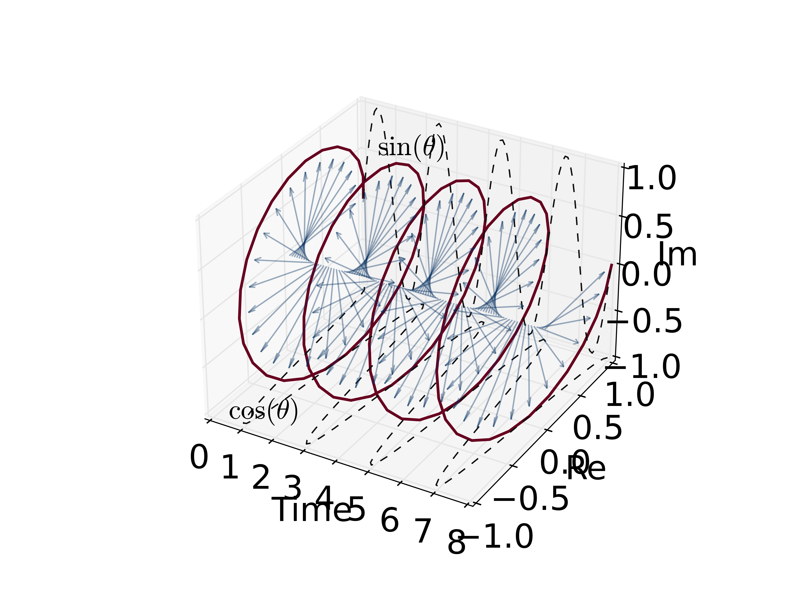

colors1 = plt.cm.Reds(np.arange(0,1,0.01))  
colors1[:,-1] = np.arange(0,1,0.01)  
  
colors2 = plt.cm.Blues(np.arange(0,1,0.01))  
colors2[:,-1] = np.arange(0,1,0.01)  
  
fig = plt.figure(figsize = (12,8))  
ax = fig.add_subplot(projection='3d')  
plt.style.use('classic')  
  
ax.scatter(time,ones,r*y1, color = colors1, marker = ",", s = 3)

> <mpl_toolkits.mplot3d.art3d.Path3DCollection object at 0x7f81c2f9c5c0>

ax.scatter(time,r*x1,-ones, color = colors1, marker = ",", s = 3)

> <mpl_toolkits.mplot3d.art3d.Path3DCollection object at 0x7f8232420e48>

ax.scatter(time,ones,r*y2, color = colors2, marker = ",", s = 3)

> <mpl_toolkits.mplot3d.art3d.Path3DCollection object at 0x7f82325be390>

ax.scatter(time,r*x2,-ones, color = colors2, marker = ",", s = 3)  
#ax.plot(time,r*x2,-ones, linestyle = '--', color = colors2[-10,:])

> <mpl_toolkits.mplot3d.art3d.Path3DCollection object at 0x7f82325bee10>

ax.quiver(time,0,0,0, 0.99*r*x1, 0.99*r*y1,   
 length = 0.9,   
 normalize = False,   
 arrow_length_ratio = 0.1,   
 alpha = 1,   
 color = colors1)

> <mpl_toolkits.mplot3d.art3d.Line3DCollection object at 0x7f81820ebe80>

ax.quiver(time,0,0,0, 0.99*r*x2, 0.99*r*y2,   
 length = 0.9,   
 normalize = False,   
 arrow_length_ratio = 0.1,   
 alpha = 1,   
 color = colors2)

> <mpl_toolkits.mplot3d.art3d.Line3DCollection object at 0x7f81c2f2a9b0>

ax.text(0.5, 1, 0.4, r'$A(t)$ $\sin(\theta)$', fontsize = 20)

> Text(0.5, 1, '$A(t)$ $\\sin(\\theta)$')

ax.text(0.5, -0.9, -1, r'$A(t)$ $\cos(\theta)$', fontsize = 20)

> Text(0.5, -0.9, '$A(t)$ $\\cos(\\theta)$')

ax.set_xlabel('Time')

> Text(0.5, 0, 'Time')

ax.set_ylabel('Re')

> Text(0.5, 0, 'Re')

ax.set_zlabel('Im')

> Text(0.5, 0, 'Im')

ax.set_xlim(0,8)

> (0.0, 8.0)

ax.set_ylim(-1,1)

> (-1.0, 1.0)

ax.set_zlim(-1,1)

> (-1.0, 1.0)

plt.show()

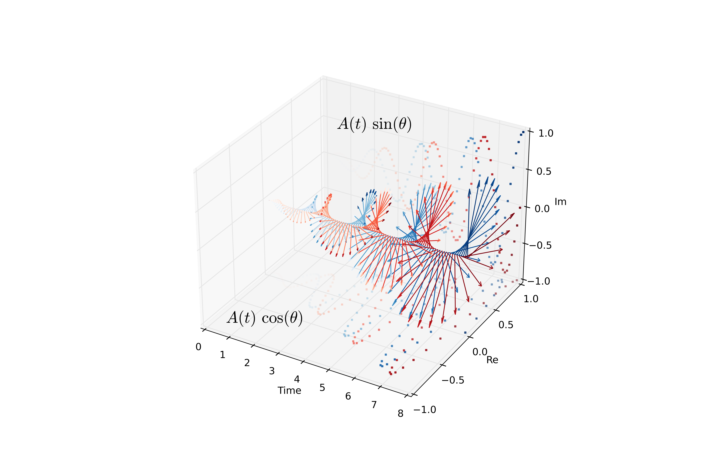

x1_vec = x1  
x1_vec = x1_vec[99]  
y1_vec = y1  
y1_vec = y1_vec[99]  
  
x2_vec = x2  
x2_vec = x2_vec[99]  
y2_vec = y2  
y2_vec = y2_vec[99]  
  
x, y = 0.0, 0.0  
  
fig,ax = plt.subplots(1)  
fig.set_figheight(6)  
fig.set_figwidth(7)  
ax.scatter(r*x1,r*y1, color = colors1, marker = ".", s = 100)

> <matplotlib.collections.PathCollection object at 0x7f82cf78e978>

ax.scatter(r*x2,r*y2, color = colors2, marker = ".", s = 100)

> <matplotlib.collections.PathCollection object at 0x7f82c41a49b0>

ax.arrow(0,0,x1_vec,y1_vec, width = 0.015, color = colors1[-1,:], head_width = 0.1)

> <matplotlib.patches.FancyArrow object at 0x7f82d62af710>

ax.arrow(0,0,x2_vec,y2_vec, width = 0.015, color = colors2[-1,:], head_width = 0.1)

> <matplotlib.patches.FancyArrow object at 0x7f82c41a4b70>

ax.add_patch(patches.Arc((x,y), 2.3, 2.3, theta1=0.0, theta2=90.0, linestyle = '--'))

> <matplotlib.patches.Arc object at 0x7f82327900b8>

ax.text(0.7,1, r'$\mathcal{\Delta\varphi = \frac{\pi}{2}}$', fontsize = 24)

> Text(0.7, 1, '$\\mathcal{\\Delta\\varphi = \\frac{\\pi}{2}}$')

ax.text(1.18*x1_vec,y1_vec, r'$\mathcal{\varphi}_{1}$', fontsize = 20)

> Text(1.18, -9.797174393178826e-16, '$\\mathcal{\\varphi}_{1}$')

ax.text(x2_vec,1.22*y2_vec, r'$\mathcal{\varphi}_{2}$', fontsize = 20)

> Text(-7.354070601250002e-16, 1.22, '$\\mathcal{\\varphi}_{2}$')

ax.set_xlim(-1.35,1.35)

> (-1.35, 1.35)

ax.set_ylim(-1.35,1.35)

> (-1.35, 1.35)

ax.set_xlabel('Re')

> Text(0.5, 0, 'Re')

ax.set_ylabel('Im')

> Text(0, 0.5, 'Im')

plt.show()

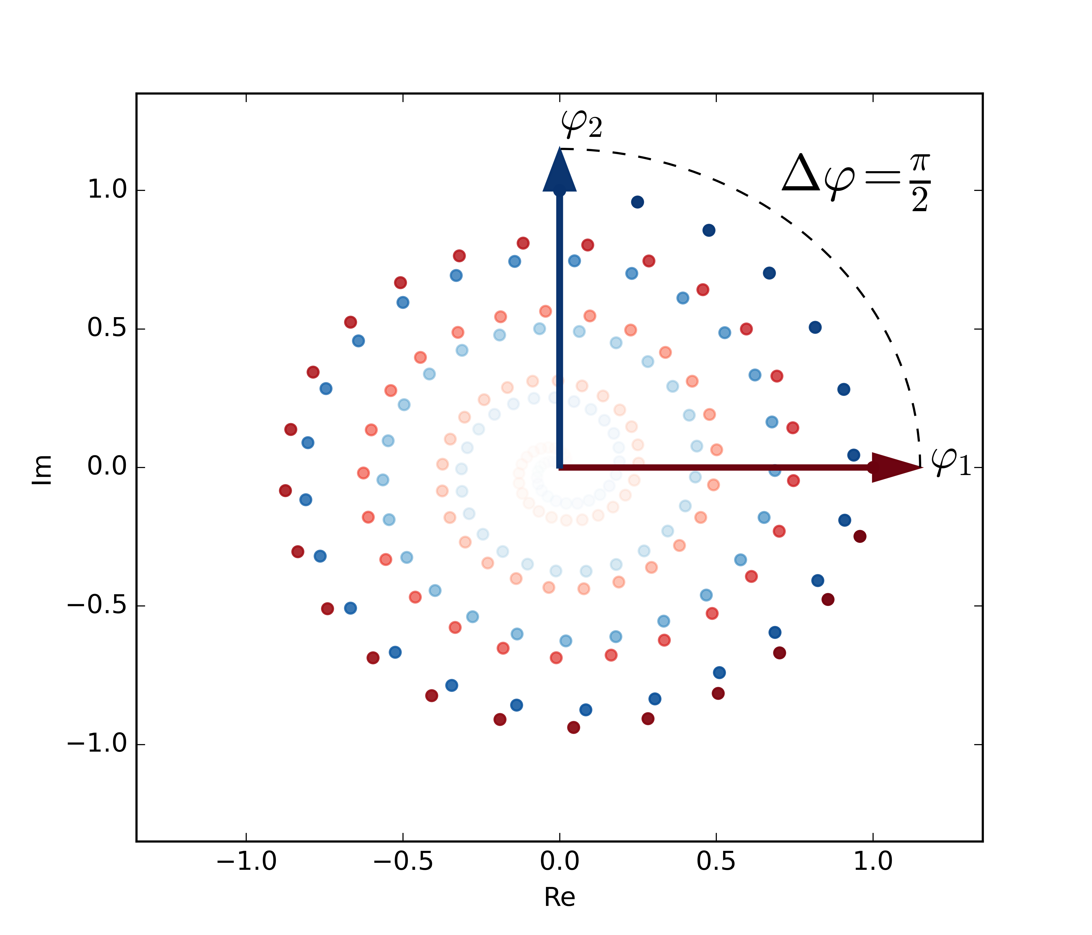

import sys  
sys.path.insert(1, 'libs/')  
  
import numpy as np  
import scipy as sc  
from scipy import io  
import dynfc as dyn  
import seaborn as sns  
import matplotlib.pyplot as plt  
  
ts = sc.io.loadmat('data/ts.mat')['ts']  
ts = ts  
  
RSsig = np.zeros((ts.shape[0],ts.shape[1],1))  
RSsig[:,:,0] = ts  
  
Phases, syncConn, leidaArray = dyn.run_multiPat(RSsig)

> Signal filtered.  
> Phases obtained.  
> Matrices obtained.  
> Routine finished for patient no. 1.

mat1 = syncConn[:,:,0,0]  
  
aa = plt.figure(figsize = [7,6])  
ax = sns.heatmap(mat1,   
 cmap = "RdBu_r",   
 vmin = -1,   
 vmax = 1,   
 square = True,   
 cbar = True)  
ax.axis('off')

> (0.0, 200.0, 200.0, 0.0)

ax.tick_params(left=False, bottom=False)  
plt.show()

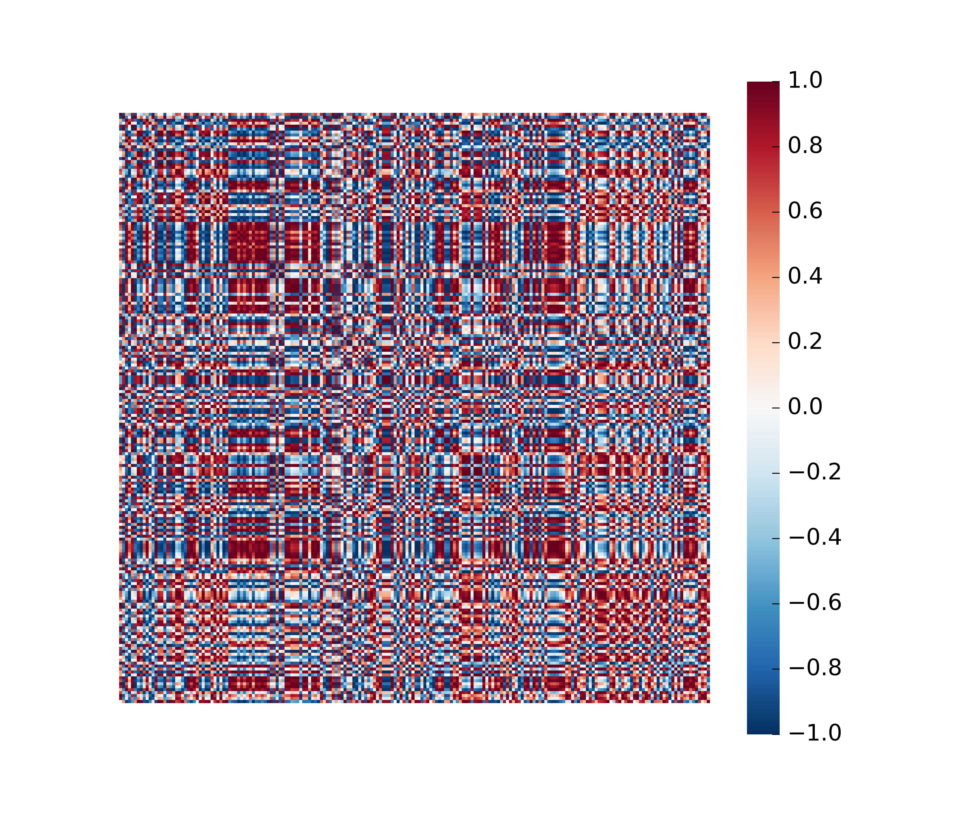

aa = plt.figure(figsize = (12/50,4))  
ax = sns.heatmap(leidaArray[:,0,]/max(abs(leidaArray[:,0,])),   
 cmap = "RdBu_r",   
 vmin = -1,   
 vmax = 1,   
 square = False,   
 cbar = False)  
ax.axis('off')

> (0.0, 1.0, 1180.0, 0.0)

plt.show()



This document was prepared on 2021-02-15.

# 4 Package References

report::cite_packages(sessionInfo())

* JJ Allaire and Yihui Xie and Jonathan McPherson and Javier Luraschi and Kevin Ushey and Aron Atkins and Hadley Wickham and Joe Cheng and Winston Chang and Richard Iannone (2020). rmarkdown: Dynamic Documents for R. R package version 2.6. URL <https://rmarkdown.rstudio.com>.
* Kevin Ushey, JJ Allaire and Yuan Tang (2021). reticulate: Interface to ‘Python’. R package version 1.18-9007. <https://github.com/rstudio/reticulate>
* R Core Team (2020). R: A language and environment for statistical computing. R Foundation for Statistical Computing, Vienna, Austria. URL <https://www.R-project.org/>.